Albert Waterman
Enhancement One Software Design and Engineering
17 July 2026
The artifact I selected is CS 340 Animal Shelter Dashboard. Originally I used Python, Dash, MongoDB, Pandas, Plotly, and Dash Leaflet. The dashboard uses animal shelter data from the Austin Animal Center and helps the user search for animals that could possibly be trained for different types of rescue work. The dashboard allows the user to filter the animal records by water rescue, mountain or wilderness rescue, and disaster or individual tracking. It also displays the records in a table, shows the most common breeds in a chart, and displays the selected animal’s location on a map. The original application worked, but almost everything was placed inside the same Jupyter Notebook. The layout, database connection, MongoDB queries, filters, chart, and map were all closely connected. Also, the map was very cluttered, and filtering columns weren’t working properly.
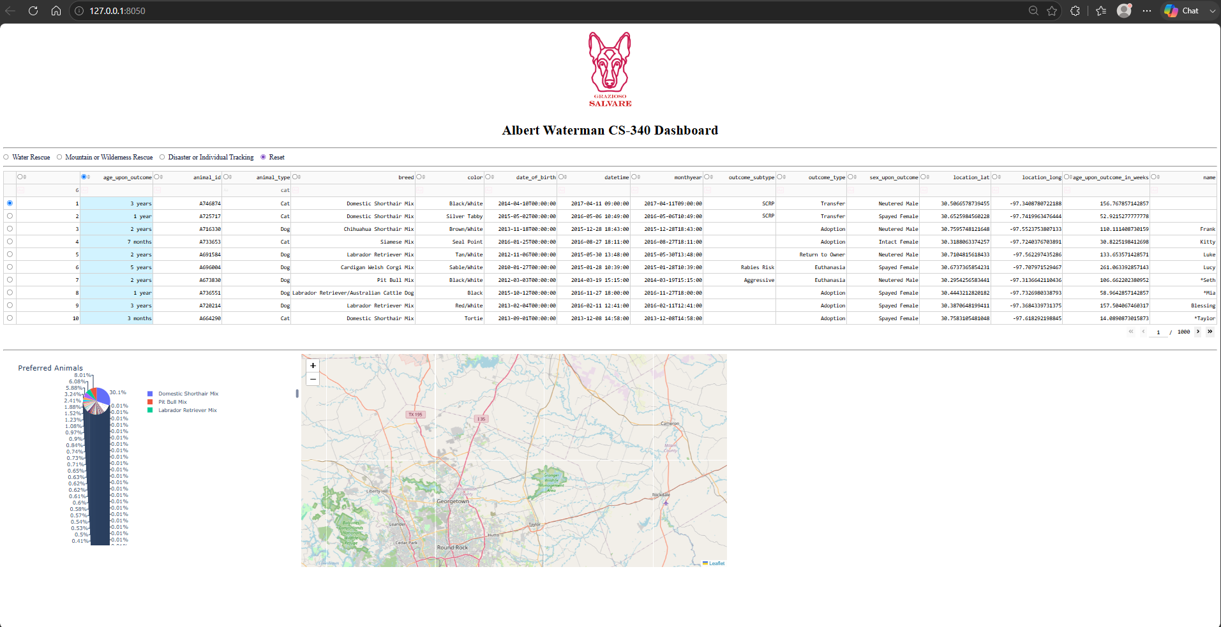
Original Dashboard
I selected this artifact because it shows several of the skills I have learned throughout SNHU. It combines software development, database access, filtering, user-interface design, charts, and maps into one working application. I also selected it because dashboards are something that connect to my current career and what I may want to do in the future. I currently work with laboratory equipment and technical systems. A dashboard like this could also be used to display equipment status, service history, system errors, maintenance records, or other information that helps employees make decisions. Even though this dashboard is based on animal shelter data, the same general skills can be used in other industries.
The original project showed that I could create a working application, but it also had areas that needed improvement. Most of the code was inside one notebook, and the dashboard callbacks were directly creating MongoDB queries. This would make the application harder to maintain if more features were added later. For my enhancement, I separated the project into three main parts. The dashboard handles what the user sees and clicks. The service layer handles the rescue filters and prepares the data. The repository layer handles the MongoDB connection and database operations.
This was one of the main goals from my Module One enhancement plan. I wanted to make the code more organized without changing the original purpose of the application.
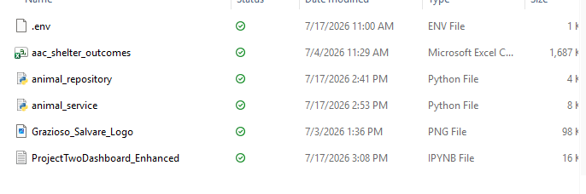

One of the main improvements was creating the animal_repository.py file. This file now handles the MongoDB connection and the create, read, update, and delete operations. The dashboard no longer needs to connect directly to MongoDB. I also added a connection timeout and a ping that checks whether MongoDB is available. This keeps the program from waiting too long if the database is not running. I also changed the error handling so it catches MongoDB-related errors instead of using a general except statement for everything. The repository still contains the create, update, and delete methods from the original CRUD class. The dashboard mainly uses the find method because its purpose is to search and display information. I kept the other methods because they were already part of the original project and could be used later if the dashboard is expanded. The second major improvement was creating the animal_service.py file. This file contains the rescue filters and prepares the information that is sent to the dashboard. The service checks that the selected rescue filter is valid, builds the correct query, and sends the request to the repository. The service also cleans the records before displaying them. For example, if information is missing, the service replaces the missing value with "Unknown" instead of leaving a blank space. It also prepares the table columns, counts the ten most common breeds, gets the selected animal’s information for the map, and converts the visible records into CSV format. Moving these responsibilities into the service class made the notebook easier to read. The dashboard callbacks no longer include all rescue rules and database queries. Instead, the dashboard can use a simpler line such as:
records = service.get_animals(filter_type)
That line sends the selected filter to the service, and the service handles the rest of the process.
I also made several improvements to the dashboard itself. I added a message that shows how many animal records were found after the user selects a rescue category. If no animals match the filter, the dashboard displays a message instead of only showing an empty table. I replaced the original pie chart with a bar chart that shows the ten most common breeds. The pie chart became difficult to read when there were many different breeds. I also improved the map. The original map used column numbers to find the animal’s latitude, longitude, breed, and name. This could cause problems if the order of the table columns changed. The enhanced version uses field names such as location_lat, location_long, breed, and name. This makes the code easier to understand and less likely to break. Another feature I added was the Export Current Results button. The user can apply a rescue filter or filter the table and then export the records currently being displayed into a CSV file. This makes the dashboard more useful because the information can be saved or shared with someone else. I also removed the hard-coded MongoDB username and password from the notebook. The enhanced application loads its connection settings from an environment file. This keeps the connection information separate from the main code and prevents private information from being uploaded with the notebook.
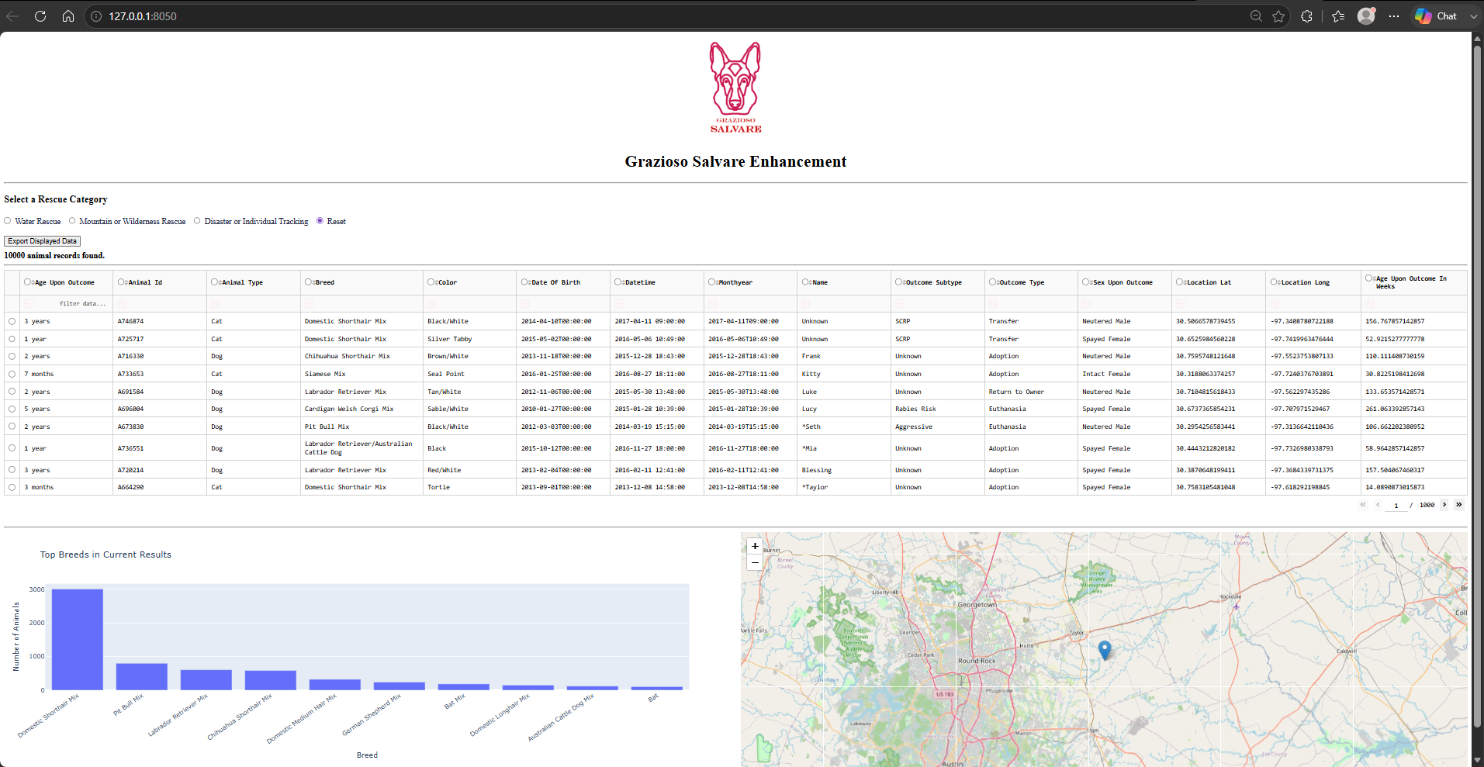

I made progress toward the first course outcome by improving how users can search, view, compare, and export the animal information. The table, filters, chart, map, and CSV export give the user different ways to understand the data and use it to their needs. I also addressed the second course outcome through the organization of my code, comments, and code review. Separating the application into different files makes it easier for another person to understand where each part of the program is located. I addressed the fourth course outcome by using Python, Dash, MongoDB, Pandas, Plotly, Dash Leaflet, Jupyter Notebook, PowerShell, and environment variables to improve a working application. I did not start over with a new project. I used the tools I have learned to make the original application better. I also made progress toward the fifth course outcome by removing hard-coded credentials, validating the rescue-filter selection, limiting the fields returned from MongoDB, and improving the error handling.
My original dashboard completed the required tasks, but too much of the code was placed together inside one notebook. Before the enhancement, I mostly focused on getting the correct result, but this process made me think more about how easy the project would be for another developer to understand. At first, splitting the code into more files was confusing because I was used to having everything in one place, but once I understood how the dashboard, service, and repository worked together, the structure made it way more organized and clear. I learned that the repository should handle MongoDB, the service should handle the filters and data preparation, and the dashboard should handle the layout and callbacks. One of the biggest challenges was making sure the table, chart, map, record count, and CSV export all continued working with the same filtered data. I also improved the error handling so the program could tell the difference between no records being found and an actual database problem. This enhancement helped me move from only thinking about whether the program works to also thinking about how it is organized, maintained, and improved over time.
References:
Plotly.express.bar — 6.8.0 documentation. (n.d.). https://plotly.com/python-api-reference/generated/plotly.express.bar

mongo_client – Tools for connecting to MongoDB - PyMongo 4.17.0 documentation

Manually raising (throwing) an exception in python - stack overflow. (n.d.-e). https://stackoverflow.com/questions/2052390/manually-raising-throwing-an-exception-in-python

